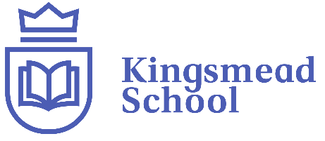

Reading Long Term Overview Cycle A – 2025-2026

Implementation – Every child is recognised as a unique individual and so, in addition to daily whole-class reading, we provide enhancement opportunities for children who require further support in achieving the age-related expectations. This might be through extra phonics support or fluency activities. We believe that all children should be given the opportunity to access the same text, safe in the supportive environment of whole class reading. Children must be exposed to the same vocabulary and themes as their peers to provide experiences and for any knowledge gaps to diminish.
Reading Vipers – Children are taught the skills of reading (outlined in the National Curriculum and the KS1 and KS2 test domains) through the use of VIPERS which were created by Rob Smith (The Literacy Shed).
Key Stage 1
In Key Stage One children reading skills are taught and practised using the VIPERS during whole class reading sessions.

KS1 Content Domain Reference [VIPER]
1a draw on knowledge of vocabulary to understand texts [Vocabulary]
1b identify/explain key aspects of fiction and non-fiction, such as characters, events, titles and information [Retrieve]
1c identify and explain the sequences of events in texts [Sequence]
1d make inferences from the text [Infer]
1e predict what might happen on the basis of what has been read so far [Predict]

Key Stage 2
In Key Stage Two children reading skills are taught and practised using VIPERS during whole class reading sessions.

KS2 Content Domain Reference [VIPER]
2a Give/explain the meaning of words in context [Vocabulary]
2b retrieve and record information/ identify key details from fiction and non/fiction [Retrieve]
2c summarise main ideas from more than one paragraph [Summarise]
2d make inferences from the text/ explain and justify inferences with evidence from the text [Infer]
2e predict what might happen from details stated or implied [Predict]
2f identify/explain how information/ narrative content is related and contributes to meaning as a whole [Explain] 2g identify/explain how meaning is enhanced through choice of words and phrases [Explain] 2h make comparisons within a text [Explain]
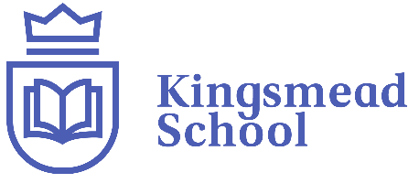

Reading Long Term Overview Cycle A – 2025-2026

Overview of Texts -
 | Autumn | Spring | Summer
Year 1/2 | Should we be forgiven for the mistakes we make? | What does it mean to belong? | Can we always believe what we see?
Range of Texts – whole class shared reading, story time and guided reading | Toby and the Great Fire of London  Daisy and the trouble with London  The Kings Pants  The Queens Hat  A Tree for all Seasons  Four Seasons Makes a year | Beegu  A Cat About Town  Sidney the Lonely Cloud  Our Tower  The Little Ghost who was a Quilt  Lost and Found  Say Hello | Insects Matter T4W  Bug Hotel by Libby Waldon  Harry the Poisonous Centipede  Because of an Acorn
Year 3/4 | Should we always do as we are told? | Can one person change the world? | Can we overcome our fears?
Range of Texts – whole class shared reading, story time and guided reading | Stone Age Boy  How to Wash a Wooley Mammoth  Icarus was Ridiculous  Beasts of Olympus | The Hodgeheg  Clean Up  The Great Kapok Tree  Rainforest Warrior | Me and My Fear  The Proudest Blue  Ruby’s Worry  The Owl Who was Afraid of the Dark
Year 5/6 | Can conflict have a positive impact on us? | How have natural disasters led to change? | Should you always speak up for what you think is right or wrong?
Range of Texts – whole class shared reading, story time and guided reading | Anglo-Saxon Boy  Viking Boy  Crookhaven the School For Thieves | A Different Kind of Freedom: A Romani Story  Space Detectives  Which Way to Anywhere  Hidden Figures | The Goldfish Boy  Boy  Children Who Changed the World  You Can Do It

